12. Create and managing index estooptimize database performance.

use dbmt;
show databases;
CREATE TABLE employee3(
id INT AUTO_INCREMENT PRIMARY KEY,
name VARCHAR(100),
email VARCHAR(100),
department VARCHAR(100),
hire_date DATE
);
INSERT INTO employee3(name,email,department,hire_date)
VALUES
('Roma','roma12@gmail.com','IT','2020-01-15'),
('Mona','mona34@gmail.com','HR','2022-03-10'),
('Riya','riya89@gmail.com','IT','2019-07-22'),
('Divya','divya76@gmail.com','Finaance','2022-11-01');
SELECT*FROM employee3;
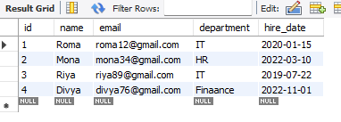

--Step 4: Create Indexes
--Index on ‘name’
CREATE INDEX idx_emp_name ON employee3(name);
--Unique Index on ‘email’
CREATE UNIQUE INDEX idx_emp_email ON employee3(email);
--Composite index on ‘department’ and ‘hire_date’
CREATE INDEX idx_dept_date ON employee3(department,hire_date);
SELECT*FROM employee3;
--Step5: View indexes

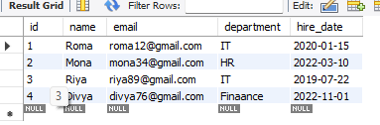

--Step6:Use EXPLAIN to see if index is used
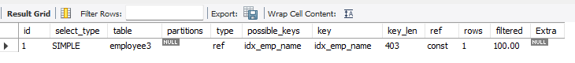
EXPLAIN SELECT*FROM employee3 WHERE name ='Roma';

